Denmark is a big shame
The sea is stained in red and in the mean while its not because of the climate effects of nature.
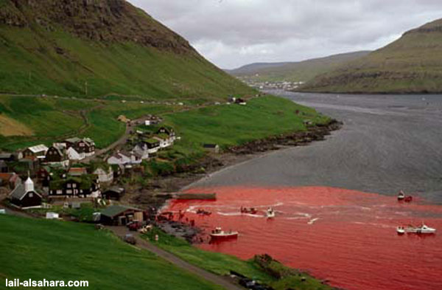
It's because of the cruelty that the human beings (civilised human) kill hundreds of the famous and intelligent Calderon dolphins.
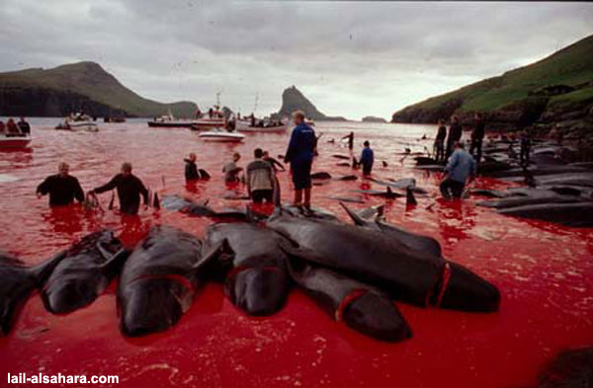
This happens every year in Feroe Iland in Denmark. In this slaughter the main participants are young teens.
WHY?
A celebration, to show that they are adults and mature!
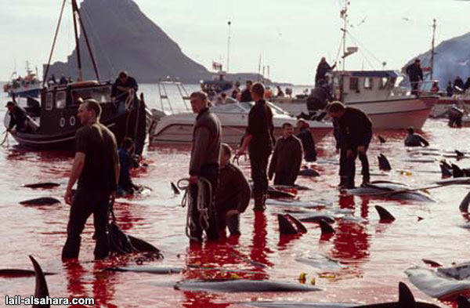
In this big celebration, nothing is missing for the fun. Everyone is participating in one way or the other, killing or looking at the cruelty supporting like a spectator
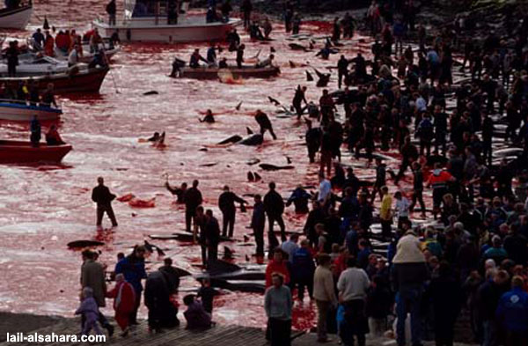
Is it necessary to mention that the dolphin calderon, like all the other species of dolphins, its near extinction and they get near men to play and interact. In a way of PURE friendship
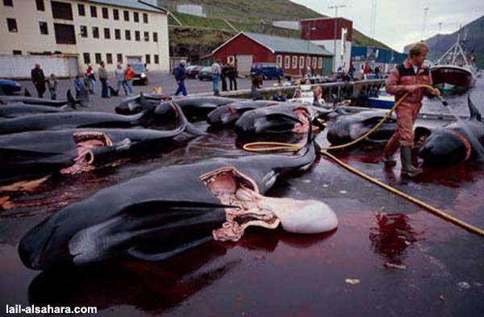
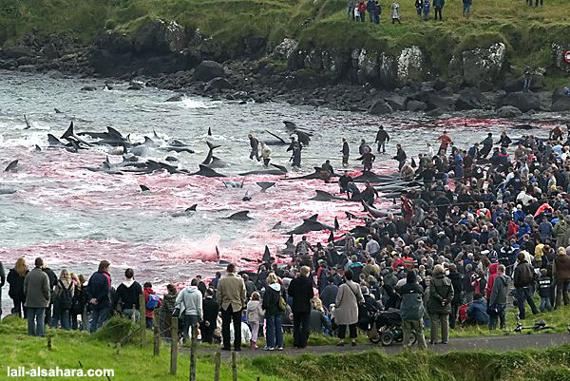
They dont die instantly; they are cut 1, 2 or 3 times with thick hooks. And at that time the dolphins produce a grim cry like that of a new born child.
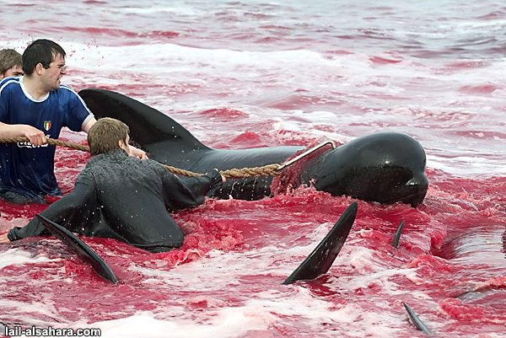
But he suffers and theres no compassion while this magnificent creature slowly dies in its own blood
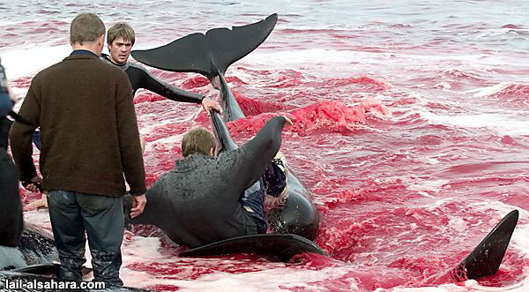
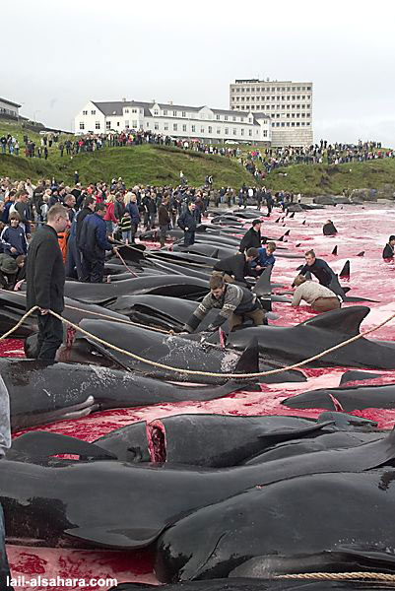
Its enough!
We will send this mail until this email arrives in any association defending the animals, we wont only read. That would make us accomplices, viewers.
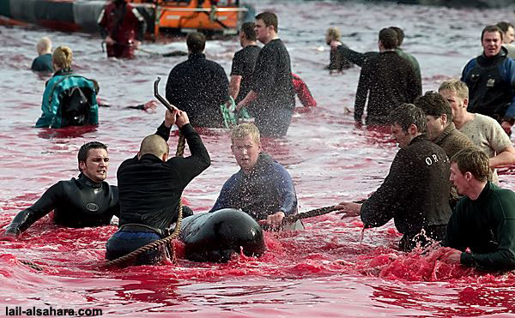
Take care of the world, it is your home!

